Voice Acting Information for :
David Ramthun
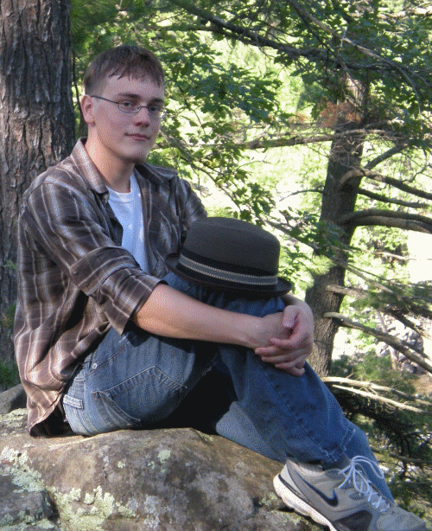

E-mail : ramthundar@hotmail.com
Website: http://ramthundarsnarrations.blogspot.com/
Location : U.S. – Minneapolis, MN
Accents : American, British (Posh, Cockney) Southern (Gentleman, Hick).
Fairly good at picking up accents, so can do any accent if a sample if provided.

Equipment: A Blue Yeti Microphone and Audacity 1.3 Beta.
Bio: David first enjoyed the fine art of acting in High School, surprising himself and others when it turned out he was actually pretty good at it. He went through several theater extra-curricular activities (Ranging from musicals and plays to One Act and Speech competitions) before finally trying out amateur voice acting. He accepted several jobs, happy in the fact that he got to do what he loved while helping create something that would make people smile. Now in college for Theater Arts and having done several volunteer projects, he continues to act for the fun and the experience, so that one day he may become a professional voice actor.
Feel free to contact David Ramthun for any of your voice acting needs!

